

Keramitra Bhavan,
Engandiyoor,Thrissur,
Kerala,India.680615

Tel: +91 487 2290300 ,2294515,9645073082
Fax: +91 487 2294515

Web: www.keratechindia.com
E-mail: info@keratechindia.com


Company Profile

We, Keratech (P) ltd, incorporated in 2008, with a paid up capital of Rs.10000000/-, have been recognized worldwide, as pioneers in manufacturing high quality coconut based products like Virgin Coconut oil, Roasted Coconut Oil, Organic Virgin coconut oil and Desiccated Coconut Powder. A wide area of farm land is used for cultivation of coconuts, using modern growing organic methods and techniques. Our impressive range of products and customer friendly services has made our brand popular in both domestic and international market. Our endeavor is to maintain a long lasting relationship with the customers.

We have dealer network all over India and abroad. We have been exporting our value added products “VIRGIN PLUS” Extra virgin coconut oil which is said to be the healthiest edible oil in the world. We have been exporting it to U.K, U.S.A, Malaysia, Singapore and Middle East (UAE, Bahrain and Muscat)

Keratech is assisted by Coconut Development Board (Ministry of Agriculture, Government of India). We are an ISO 9001:2008 certified company and we are awarded NSIC–CRISIL SE 3B rating. Quality Assurance from Kerala Agricultural University, Directorate of Research.

Vision & Mission

We aim to make available purely natural Virgin coconut oil which is the healthiest edible oil in the world at an affordable price. We started small scale industry (MSME) in this Village with a view to promote employment opportunities in the rural areas particularly among the women and also to assist the coconut farmers by assuring stable and reasonable price for their product.

Our Products

Organic virgin coconut oil
Virgin Coconut oil
Premium Micro filtered Coconut Oil
Desiccated coconut powder
Mouth wash
Massage Oil
capsule
Hair oil
Baby oil
Hair Cream

The above products are already available in the market

Technology

We are using Coconut Development Board (Ministry of Agriculture, Government of India) proposed CFTRI technology as well as Direct Micro Expelling (DME) technology.

Location

Our factory is located at Engandiyoor Village –situated in the industrial area of Thrissur District, approximately 70 Kms from Cochin Shipyard.

Our Growth Pattern

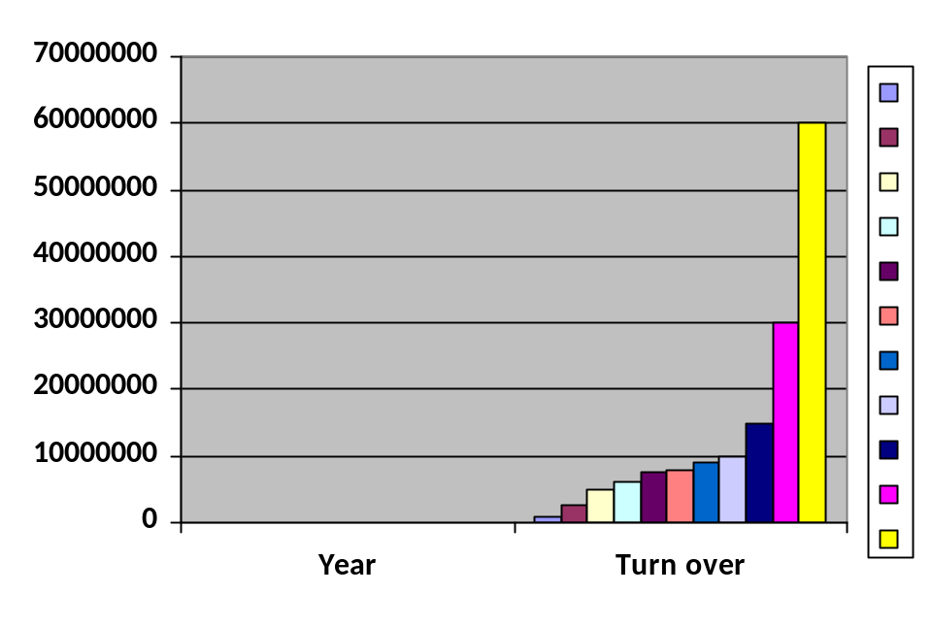

Product Specification

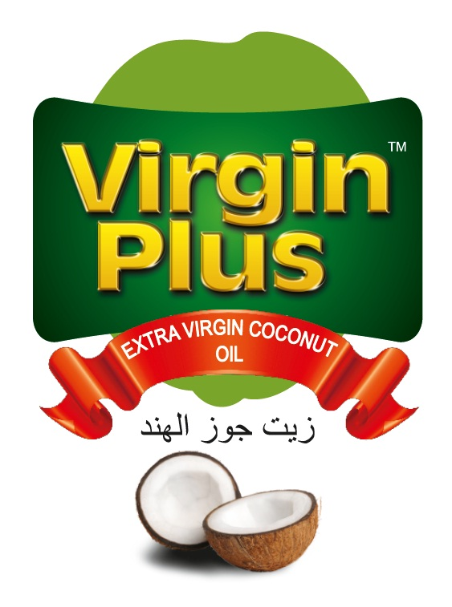

“VIRGIN PLUS” Virgin coconut oil (VCO) is the purest coconut oil, extracted from freshly shredded and first pressed coconut meat of mature coconuts. It is neither bleached nor does it undergo any deodorizing process. It doesn’t posses any odor, but spreads the fresh aroma of coconut oil.
Virgin Coconut Oil also called “White Coconut Oil” is composed primarily of medium chain fatty acids (MCFA) and triglycerides; VCO is the most healthy and versatile of all vegetable oils. Moreover, MCFA are quickly digested and are transformed by the body as energy, implying that VCO does not produce fat and cholesterol. Saturated fats found in VCO are actually good and promotes health.
The high Lauric acid content makes VCO a natural antibacterial, antiviral and anti-fungal substance. Being stable, it does not oxidize easily. As a result, Vitamins A, C and E, which strengthen the body's immune system, are not depleted. Also, Vitamin E present in the oil smoothens the hair and skin.
Lauric Acid, which is available naturally only in mother's milk, is present in VCO. This makes it very unique. These medium chain fatty acids help improve the nutrient absorption and digestion functions of the body. In addition, they help regulate blood sugar level and protect the body from harmful micro organisms.
Virgin coconut oil helps to reduce weight as the MCFA are sent directly to the Liver, where they are converted to energy rather than circulating them into the blood stream as fat. It’s also an ideal Immune System supporter. For this reason, it’s now being studied as a treatment for HIV/AIDS. Furthermore, it inhibits induction of carcinogenic properties and improves Cardio Vascular Health. With these remarkable properties VCO is 10 times more enriched in nutrients and far healthier than ordinary coconut oil.

"VIRGIN PLUS” Extra Virgin COCONUT OIL - A brief description

"VIRGIN PLUS" Extra Virgin Coconut oil, extracted from fresh coconut kernel by Direct Micro Expelling Technology, is of very high quality and commands a premium price because of its use as a health product. This is a highly sought after item as a health product and is used as cooking oil, hair oil, and also as baby oil for massaging small kids. Coconut oil is a much sought after product for edible use in the households and non-edible use as hair oil and as cosmetic and industrial oil.

- Processed from farm fresh green coconuts of the coastal parts of Kerala in India– Gods own country and the land of coconut trees.
- Usage of cold processing technology by which coconut oil is extracted from fresh, mature, green coconuts within hours of plucking
- Unrefined; Non bleached and Non-deodorized
- Absolutely free from chemicals and preservatives
- Does not contain ‘Trans-fats'
- Non fermented; unhydrogenated
- As pure as fresh coconut; tastes like fresh coconut
- Has the mild natural fragrance of farm fresh coconuts
All vegetable oils are not natural. Many are extracted with chemical solvents and are highly processed where its natural characteristics are altered. There is no comparison between "VIRGIN PLUS" Extra Virgin Coconut oil and ordinary coconut oil. In sharp contrast, "VIRGIN PLUS" Extra Virgin Coconut oil tastes like fresh coconut, smells the natural aroma and has got brilliant transparent color.
"VIRGIN PLUS" Extra Virgin Coconut Oil as COOKING OIL
"VIRGIN PLUS" Extra Virgin Coconut oil is an excellent cooking oil, which enhances the flavor and taste of many recipes and cuisines. It is zero cholesterol oil which is rapidly metabolized by the human body into energy and not cholesterol. The nutritional and medicinal values of “VIRGIN PLUS” Extra virgin coconut oil are not lost in heating because of its very high ‘smoke point’. Cooking or baking with "VIRGIN PLUS" Extra Virgin Coconut oil, which is rich in dietary fiber, calcium, iron and low in carbohydrates can assist you in reducing your blood pressure.
"VIRGIN PLUS" Extra Virgin Coconut Oil as MEDICINE
The main content of virgin coconut oil is “Lauric Acid” which is found in mother’s milk only
- Its highest content of Lauric Acid builds up the natural immune power of human body thereby making it resistant to many of the bacteria, fungi and viral infections.
- The anti viral, anti microbial, anti fungal and anti protozoa properties of Medium Chain Fatty Acids (C₈,C₁₀,C₁₂) with Lauric Acid (C₁₂) and its monoglycerides form, monolaurin being mentioned as the most potent against lipid coated micro organisms which are not normally cured by ordinary antibiotics.
- The Lauric Acid is converted into Monolaurins in human body which is known to destroy “Lipid Enveloped Viruses” such as Measles; Vesicular Stomatitis Virus; Herpes Simplex Virus (HSV – 1; Cytomegalovir (CMV) Virus; Influenza and effective even in HIV and Best Defence to H1N1 – Swine Flue.
- Medium Chain Fatty Acids (C₈,C₁₀,C₁₂) is directly converted into energy in the Liver and increases the metabolic rate of an individual. Thus VCO is an excellent source of instant energy to sportsman, elderly people and children.

- Increases the good cholesterol levels of HDL and simultaneously reduces the bad cholesterol levels of LDL thereby decreasing obesity and overweight.
- Virgin coconut oil is a best natural Antibiotic.
- Its regular usage corrects the metabolic rate thereby prevents over eating and weight gain.
- Effective in thyroid disorders like hyperthyroidism
- Virgin coconut oil is enriched with Natural Vitamin E which is not found in other vegetable oils.
- Eliminates H-Pylori bacteria, which is the root cause of hyper acidity and stomach ulcers.
- Helps to control blood sugar levels in diabetic patients.
- Its external application prevents many of the dermatological problems like dry skin, scaling and flaking of skin; Eczema; Psoriasis etc.
"VIRGIN PLUS” Extra Virgin Coconut Oil as COSMETICS
- As a hair tonic it prevents hair fall; stimulates abundant hair growth, effectively fights dryness of scarp and dandruff.
- As a body manages oil, it nourishes and moisturizes the skin, prevents drying, scaling and flaking of skin. Removes wrinkles and sagging of skin and gives a youthful skin
- "VIRGIN PLUS" Virgin Coconut Oil is the best natural TONIC for body skin and rich in vitamins like vitamin – A; D; E & K and slows down the ageing process because of its antioxidant qualities.
- As natural baby oil, it nourishes the baby skin besides moisturizing it. Its bactericidal, fungicidal and protect the baby from various infections. It is an excellent remedy for diaper rash and keeps the baby skin soft and supple.
- Many of the international brands of baby oil are prepared with mineral oil – petroleum distillate – with added dosages of synthetic perfumes and color.
- "VIRGIN PLUS" Extra Virgin Coconut oil is having mill greasy residue. It is non sticky and quickly absorbed into body tissues and hair follicles.
- It helps in the regeneration of skin cells and prevents excessive.

How long does "VIRGIN PLUS" Extra Virgin Coconut Oil last?
"VIRGIN PLUS" Extra Virgin Coconut Oil does not need to be kept in the refrigerator. VCO is the most stable among the plant oils being traded in the world. Its natural anti oxidants give it the longest shelf life compared to other oils.
Important Note.
The information's provide here is not in any way meant to encourage you to substitute VCO for the drugs or antibiotics being prescribed by your Doctor in treating illness. Please take note that VIRGIN COCONUT OIL IS NOT A DRUG BUT A FUNCTIONAL FOOD and should only be used as such.

Premium Micro filtered Coconut Oil.
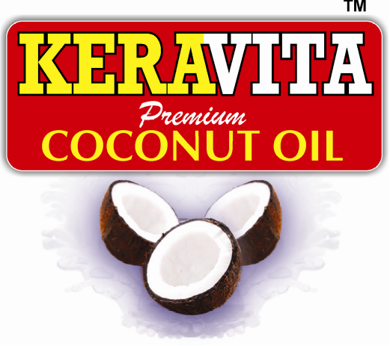
“KERAVITA”Premium Micro filtered Coconut Oil is prepared using best copra. Copra is selected, sorted and dried to remove moisture using dryer and expeller. This ensures its good aroma and long life. This oil is used as premium quality cooking oil and body massage oil. This premium coconut oil is also considered as hair oil.

“KERAVITA”Roasted Coconut oil

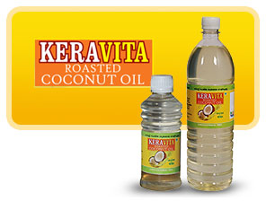
We manufacture Keravita Roasted Coconut Oil using the best copra. Copra is selected, sorted and dried using dryer and expeller. Through this process moisture is completely removed hygienically. This oil ensures its good aroma and long life. This oil is used as premium quality cooking oil and body oil. It is preferred as a fat in the preparation of filled milk, infant milk powder, ice cream, and confectionery and bakery products. It can be used for manufacturing margarine and shortenings.

- Edible in form
- Light yellow color
- Essential ingredient in ghee substitutes
- Ideal for deep frying
- Ideal confectionery fat
- Provides moisture barrier and imparts high gloss for bakery items in spray oil use
- Effective heat transfer agent in frying
- Better shelf life for fried product
- Contributes to Palatability
- Blends well with other oils

"VIRGIN PLUS" Desiccated Coconut Powder

Coconut has been the staple food of people in many parts of Asia and Pacific Islands. The dehydrated shredded flesh of coconut known as desiccated coconut is often used as a substitute to grated coconut in food preparations such as curries, cakes, sweets and chutneys. Confectionery and bakery units are the main consumers of desiccated coconut. Desiccated Coconut Powder is obtained by drying grounded or shredded coconut kernel after the removal of brown testa. It finds extensive use in confectioneries, puddings and many other food preparations as a substitute to raw grated coconut.

The “VIRGIN PLUS” personal care range of beauty and Herbal Virgil coconut oil base products reflects the very essence of natural care for your skin, hair and body.

Contact us

Tel: +91 487 2290300, 487 2294515

Fax: +91 487 2294515

Web: www.keratechindia.com
E-mail: info@keratechindia.com

